Advocacy Digest | June 18, 2021
Brad Boycks, Executive Director

POWTS Bill Clears State Senate
Recently, our bill to provide additional plan reviewers at the Department of Safety and Professional Services to review Private Onsite Wastewater Treatment Systems passed the state senate on a 29-4 bipartisan vote.
You may remember that this bill passed the state senate last session but not the state assembly.
We are now working on passage of this bill in June by the state assembly so it can be forwarded to Governor Ever for his signature soon.
WBA Joins Coalition on Worker Shortage
The Wisconsin Builders Association has joined a coalition effort asking Governor Evers’ to end federal pandemic unemployment benefit enhancers and return to pre pandemic levels to help elevate the worker shortage in our state.
In addition to this coalition effort, legislation to address this issue has been introduced as Senate Bill 354 and Assembly Bill 336.
Please click the enclosed links for the letter to Governor Evers and for more information and to review SB 354 and AB 336.
Developer Check List Draft Coming Soon
WBA is working with WBA Outside Legal Counsel Robert Procter on a Wisconsin specific “developers checklist” that eventually will be made available to all members on the members only side of our website. We are working to have a draft ready for review in the next month.
If you are a developer and would like to help review the initial draft of the developers checklist, please send an email to bboycks@wisbuild.org.
Evers Announces Reelection Bid
In a speech to the Democratic Party Convention recently, Governor Tony Evers announced he will be seeking reelection in 2022.

In that speech Evers said, “Wisconsin, I’m in. I’m running for re-election. We’ve accomplished a lot in the last few years, but we’re just getting started. We have more work to do, together.”

The most visible and well-known likely candidate on the GOP side is former Lt. Governor Rebecca Kleefisch but other individuals have been mentioned as possible candidates to run in the GOP primary to challenge Governor Evers in November 2022.

Building a Better Wisconsin PAC Action

Thank you to those that participated in the first ever WBA online auction to support the Building A Better Wisconsin PAC.

Collectively we were able to raise over $4,800 from contributions across the state. Thank you to all the winning bidders.

Also thank you to Mike and Ron Derrick, Andy Voeltner, and Greg Schaffer for donating items to WBA that were then donated to the Building a Better Wisconsin PAC to be used in the auction.

Stay tuned for future online silent auctions to fund the Building A Better Wisconsin PAC!

Rising Material Challenges, Declining Builder Sentiment
BY ROBERT DIETZ
Rising material prices and supply-chain shortages resulted in builder confidence dipping to its lowest level since August 2020. The latest National Association of Home Builders (NAHB)/Wells Fargo Housing Market Index (HMI) shows that builder confidence in the market for newly built single-family homes fell two points to 81 in June. Despite the monthly decline, the reading above 80 is still a signal of strong demand in a housing market lacking inventory.
Higher costs and declining availability for softwood lumber and other building materials pushed down builder sentiment in June. These higher costs have have moved some new homes beyond the budgets of prospective buyers, which has slowed the strong pace of home building. Policymakers need to focus on supply-chain issues in order to allow the economic recovery to continue.
While builders have adopted a variety of business strategies including price escalation clauses to deal with scarce building materials, labor and lots, unavoidable increases for new home prices are pushing some buyers to the sidelines. Moreover, these supply-constraints are resulting in insufficient appraisals and making it more difficult for builders to access construction loans.
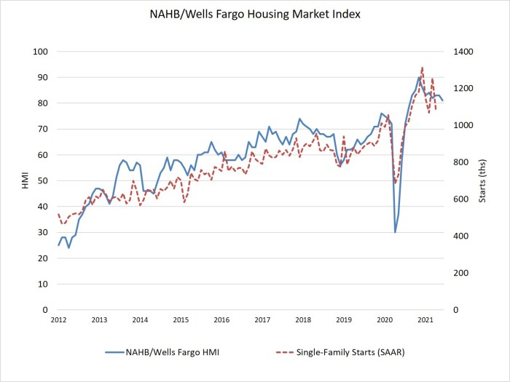
Derived from a monthly survey that NAHB has been conducting for 35 years, the NAHB/Wells Fargo HMI gauges builder perceptions of current single-family home sales and sales expectations for the next six months as “good,” “fair” or “poor.” The survey also asks builders to rate traffic of prospective buyers as “high to very high,” “average” or “low to very low.” Scores for each component are then used to calculate a seasonally adjusted index where any number over 50 indicates that more builders view conditions as good than poor.
All three of the major HMI indices posted declines in June. The HMI index gauging current sales conditions fell two points to 86, the gauge charting sales expectations in the next six months posted a two-point decline to 79 and the component measuring traffic of prospective buyers dropped two points to 71.
Looking at the three-month moving averages for regional HMI scores, the South rose one point to 85, the West fell one point to 89, the Midwest dropped three points to 72 and the Northeast posted a five-point decline to 78.
The HMI tables can be found at nahb.org/hmi.

