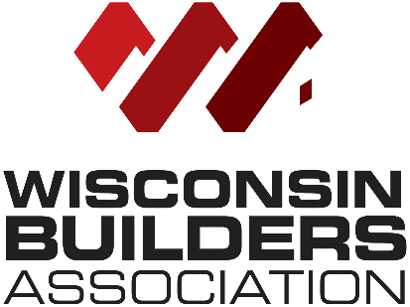
2021-2022 Advocacy Agenda

Building and code issues:
- Assure municipalities are not able to use “police powers” to regulate things like shoreland zoning and one and two-family building codes
- Clarify that homes that proceed without a final inspection as stated in SPS 320.10 (3)(h)(2), “Occupancy may proceed in accordance with local ordinances if the inspection has not been completed by the end of the fifth business day following the day of notification or as otherwise agreed between the applicant and the department or municipality”, would not affect the ability to then receive an occupancy permit
- Work with the Joint Committee for the Review of Administrative Rules to change the commercial building code that requires “two exits or exit access doorways from any space” which is a cross reference to IBC 10006.2.1.
- Changes to the contractor certification requirements per the WBA Contractor Certification Subcommittee with recommendations from the Advocacy Group on 6.24.20

Development Issues:
- Changes to TRANS 233 to allow flexibilities for minor projects in highway right of ways, utility easements, and buffer areas (landscaping, signs, parking lots) that the current rule does not allow
- Reintroduction of “Workforce Housing Tax Incremental District” provision if not passed to conclude the 2019-2020 legislative session
- Clarifying statute changes on bonding used for infrastructure and the process for conditional use permits
- Preempt the use of statutory protest by municipalities
- Working with the League of Municipalities to pass a statute that requires all municipalities to connect roads between them. Many town’s refuse to allow a village or city to connect to the town’s roads to prevent development and annexations.
- Incorporate into the annexation statute a definition for contiguity that reflects the Wisconsin Supreme Court’s opinion in the Kohler annexation case

Impact Fees:
- Review the current impact fee state statutes and consider recommendations to modernize and streamline the process for collection of these fees

Tort Reform Issues:
- As a member of the Wisconsin Civil Justice Council, continue to support legislative and state budget initiatives “promoting fairness and equity in Wisconsin’s Civil Justice System”

Tax/Business Issues:
- Maintain current law regarding Use Value Assessment of agricultural land

Remodeling Issues:
- Continue to pursue changes to DATCP 110 either via administrative rule change or legislative change to make it easier to follow to assure compliance

